

**Insertion of the AAU BIC or the Direct Debit mandate in the registration form**

The registration form allows for the creation of unlimited AAU BICs Or Direct Debit Mandates using a .txt file. For participants with a large number of AAUs or Direct Debit mandates the .txt file will in any case be the preferred option.

**CASH ACCOUNT - Authorised Account User**

Please note that the .txt file to create the Authorised Account Users must follow the below order and contain the following information:

CashAccountNumber, AuthorisedUserBic, MaximumIPAmount, ParticipationType

The name of the .txt cannot contain spaces (e.g. authorised_ account_user).

Be reminded that the Maximum IP Amount is the maximum amount accepted by the TIPS Participant or Reachable Party for an incoming Instant Payment Transaction and can be inserted only by TIPS participants.

The possible values for Participation Type are:

• DIRE = Direct

• INDI = Indirect

• MADI = Multi Addressee – Branch of Direct Participant

• MACI = Multi Addressee – Credit Institution

• ADCO = Addressable BIC - Correspondent

• ADDI = Addressable BIC – Branch of Direct Participant

• ADIN = Addressable BIC – Branch of Indirect Participant

• ADBC = Addressable BIC – Branch of Correspondent

• EXCL = Excluded BIC from a Wildcard Pattern

**EXAMPLE OF TXT FILE CONTENT for TIPS Participant**

DE111000000123456, DE00000XXXY, 10000000, DIRE

DE222000000123456, DE00000XXXY, 10000000, INDI

DE333000000123456, DE00000XXYY, 10000000, ADIN

DE444000000123456, DE00000XYYY, 10000000, ADBC

**EXAMPLE OF TXT FILE CONTENT for non TIPS Participant**

(the space between the BIC and the participation type where the maximum amount for instant payments would be inserted must be included)

DE111000000123456, DE00000XXXY, , DIRE

DE222000000123456, DE00000XXXY, , INDI

DE333000000123456, DE00000XXYY, , ADIN

DE444000000123456, DE00000XYYY, , ADBC

A wildcard may also be submitted as the AAU of a cash account

RFIEURBANKFIHHXXX001, BANKSE*, , MADI

In this case a BIC can also be excluded from the wildcard using the code EXCL

RFIEURBANKFIHHXXX001, BANKSEGGXXX, , EXCL

**CASH ACCOUNT - Direct Debit Mandates**

Please note that the txt file to create the Direct Debit Mandates must follow the below order and contain the following information:

PayeeParentBIC, PayeePartyBIC, FromCashAccountNumber, PayeeReference, MaximumAccountPerCounterparty, MaximumAccountPerPayment

The name of the .txt cannot contain spaces (e.g. direct_debit_mandates).

**EXAMPLE OF TXT FILE CONTENT**

(the spaces must be included)

DE00000XXXY, DE00000YYYY, DE111000000123456, DEREFXXX, 100000, 1000

**Editing the Registration Form**

After having compiled the Registration Form and clicked on the ‘Finish Registration’ button, a signature pop-up will appear. Please click ‘OK’ and check the data.

**EDITING**

**Please be aware that Edit mode only applies to the editing of a field which was incorrectly inserted. If during the registration whole blocks were not inserted, then the form should be closed without saving and the process should be started again from the beginning.**

If you need to modify any field in the Registration Form via the ***Edit button*** at the bottom of the Data sheet two scenarios can be possible:

1. The Registration Form is still open on your desktop and you did not close and save it 🡪 please follow the instructions in Annex 1.
2. The Registration Form has been saved and closed 🡪 please follow the instructions in Annex 2.

***Annex 1***

* If you need to: modify previously inserted information, insert new data in left blank fields of previously compiled sections, compile a section you did not populate before.
* Please click on **Edit** and go straight to the field/section you would like to modify and proceed with the amends/insertions.
* Click on **Finish Registration**.

***Annex 2***

* If you need to: modify previously inserted information, insert new data in left blank fields of previously compiled sections, compile a section you did not populate before.
* Please click on **Edit** and, to correctly complete the modifications/insertions of the Registration Form, **go through all the sections** you have previously completed or partially completed, following the order of the Form Menu.

*In principle, all the sections/fields/additional buttons compiled before having saved the Registration Form must be saved again (via the* ***Save/Continue/Menu Form*** *buttons) in order to be visible in the Data sheet.*

* Click on **Finish Registration**.

Please find below an example on how to use the Edit button when the Registration Form has been saved and closed.

Scenario: the Registration Form has been compiled with the data currently shown in the screenshots and the user needs to amend some ticks in H) Roles (1. Party section) and to insert some information in 2. Cash Account, section G) Direct Debit Mandate:

1. The first view is on the Opening Form:

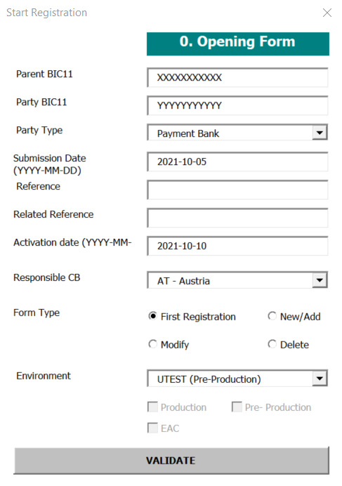

1. After clicking on **Validate**, the user starts to follow the structure of the Form Menu, so starting from 1. Party:

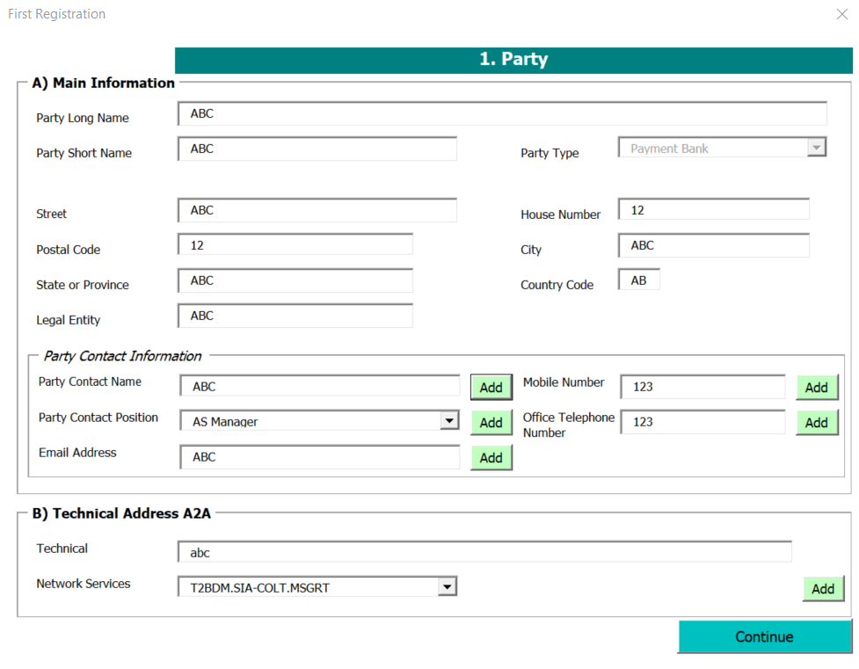

1. In this case, the user has previously populated the **Add** functionality of the ‘Add Contact name’ field, so he **must click on Add** and **Save it again**, and click on **Continue**:

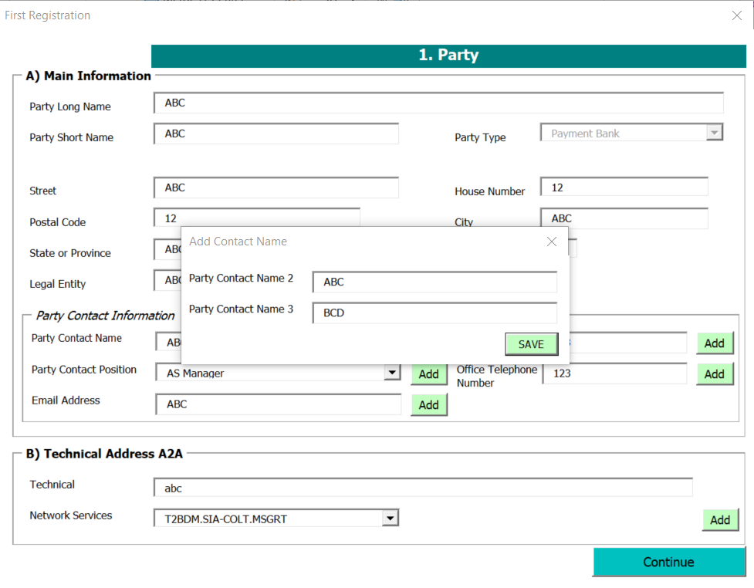

1. Then, the section C) Party Service Link is shown, in this case the user did not add any Party Type to link before saving the file, so he does not need to re-enter this field. The user clicks on **Continue**:

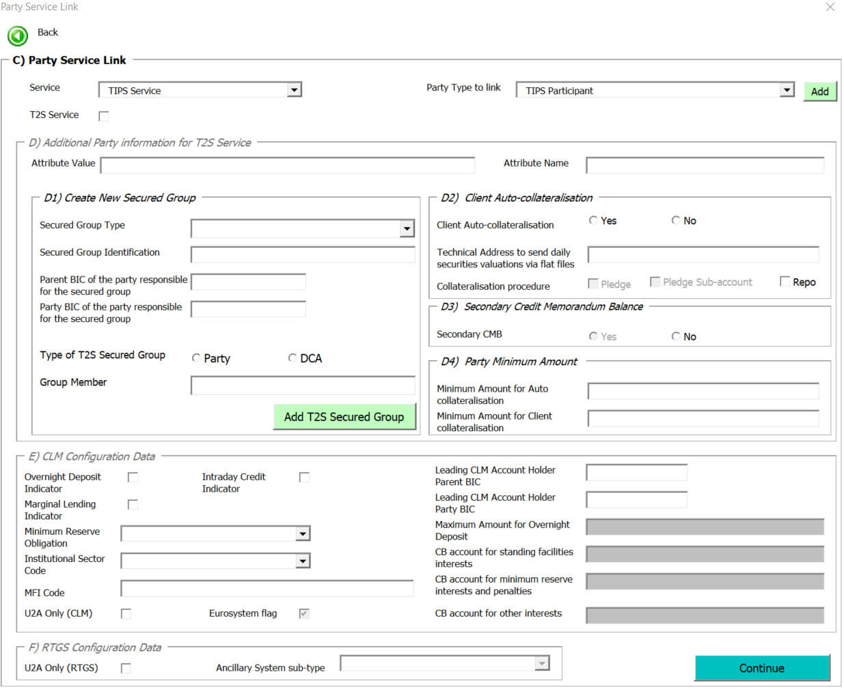

1. Next view is shown, and the user just needs to click on **Continue**:

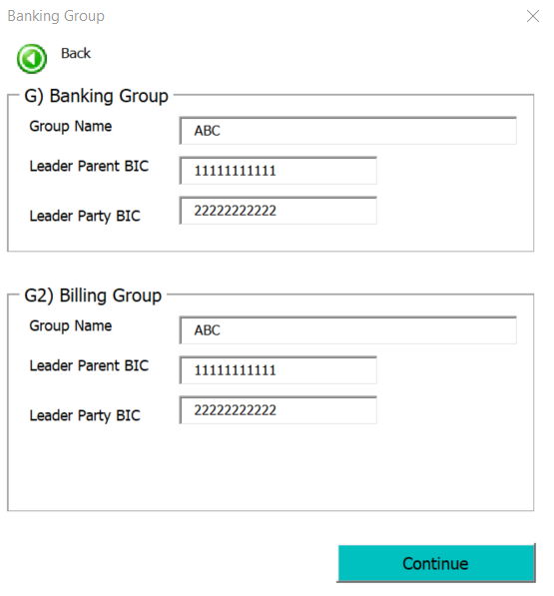

1. The user is now able to amend the ticks in the view H) Roles. The user proceeds with the modifications and click on **Menu**:

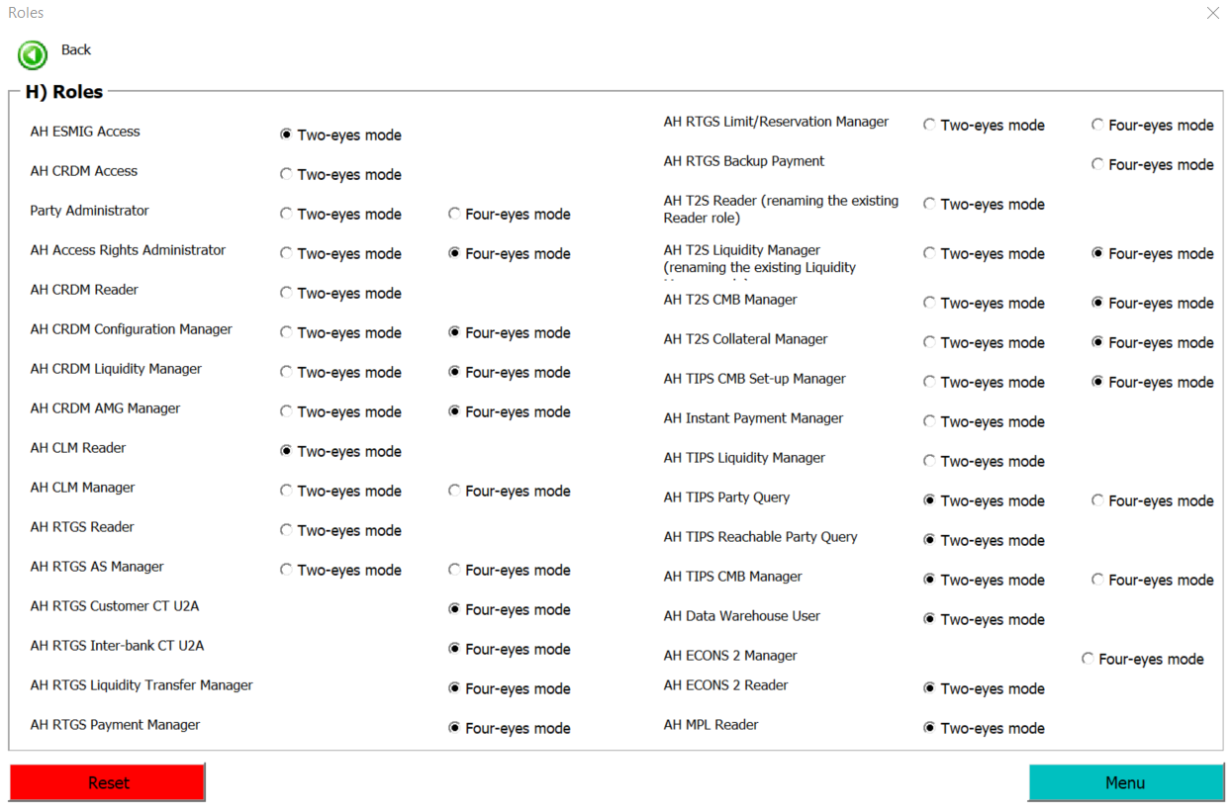

1. The user enters the next section following the Form Menu order:

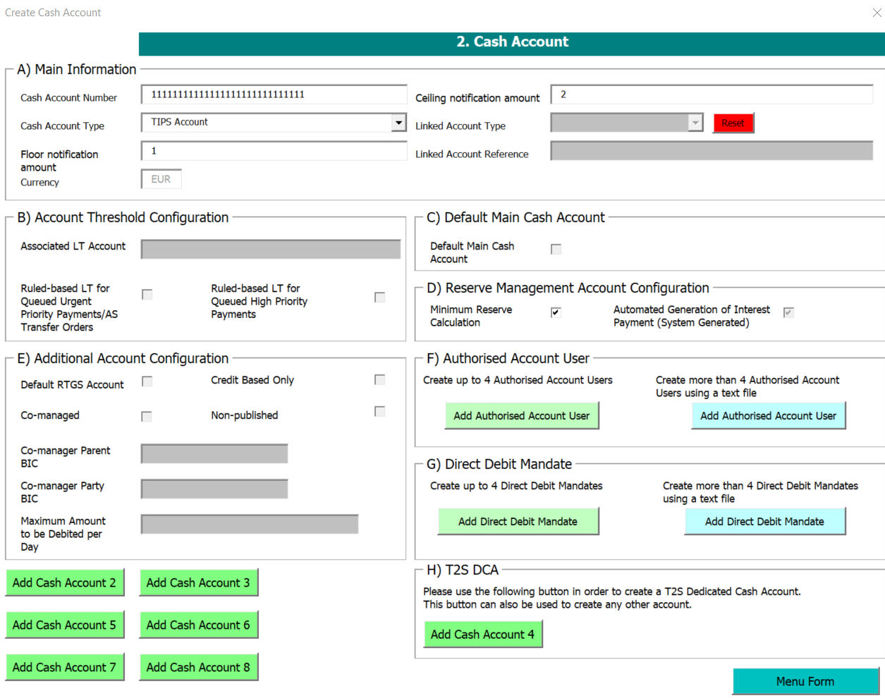

1. The user inserts the additional information needed to the section G) Direct Debit Mandate, then click on **Save**:

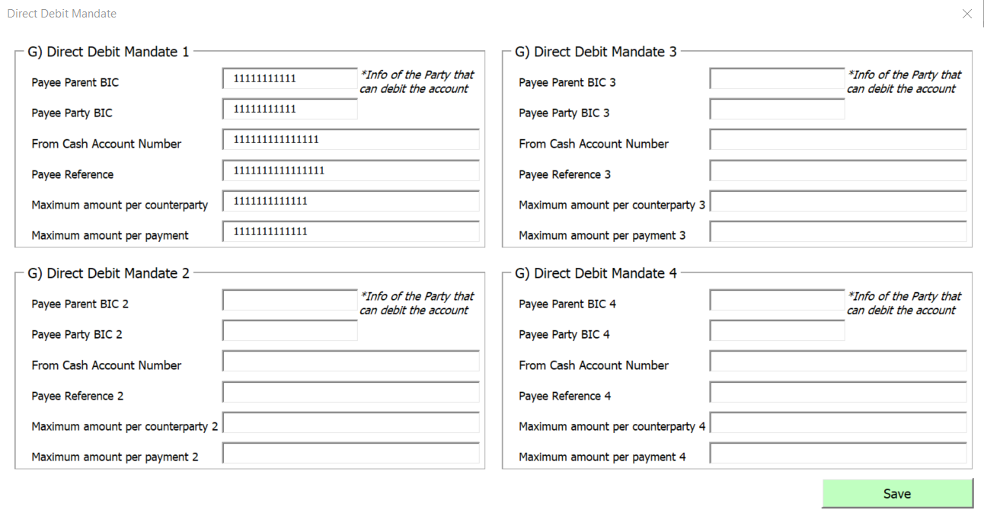

1. Before going back to the Menu Form, the user needs to click on Add Cash Account 2, because **it was previously filled in** and it contains information that needs to be saved again:



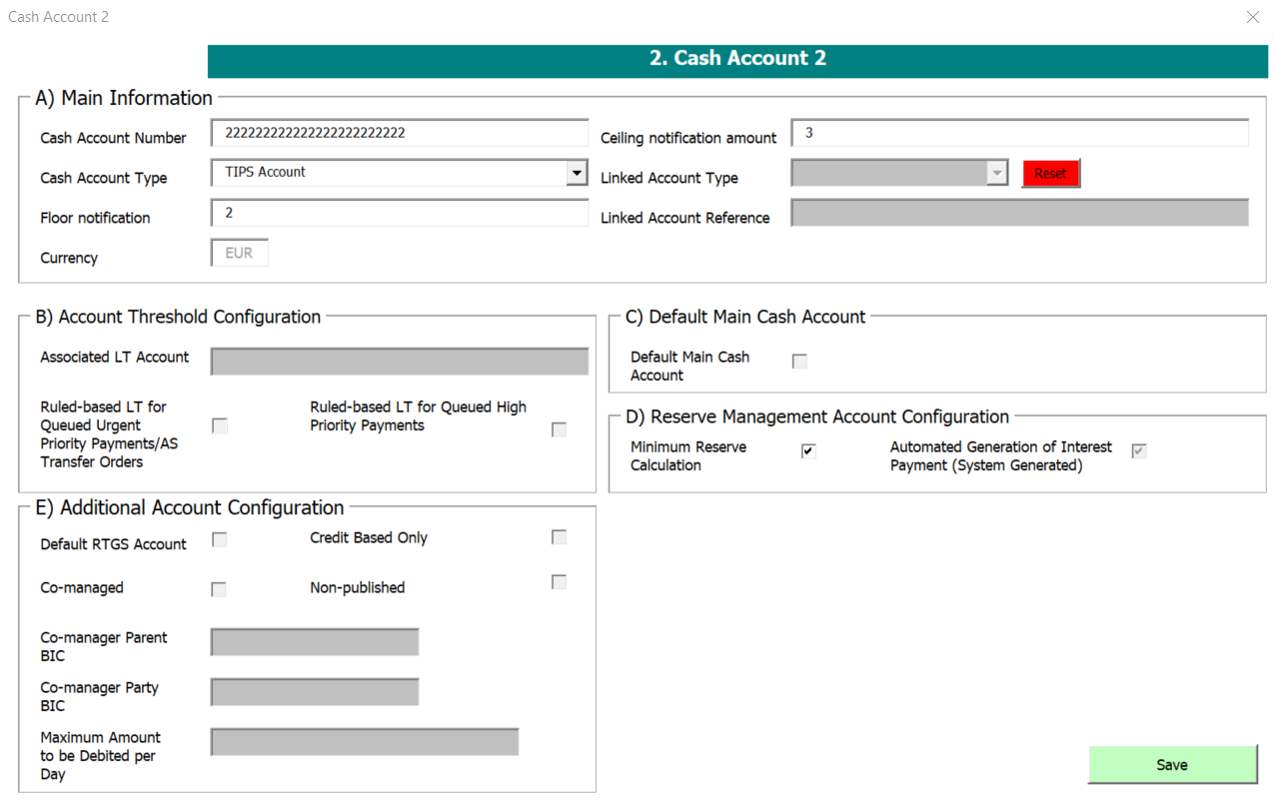

1. Once in the Menu Form, the user clicks on 4) Setting Up Administrator User section and, without editing or adding any information, clicks on **Form Menu** (in this way, the information stored in this section will be saved again in the Data sheet):

